DATE: 23.08.2019
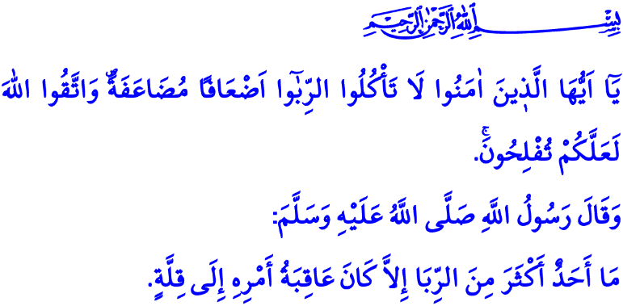
SOCIAL HARMS OF INTEREST
Dear Muslims!
It was tenth year of hijrah and the last year of prophecy. Prophet Muhammad (saw) set off from Medina and arrived Arafat with his companions in order to perform hajj obligation. There, he recited his khutbah that will be known as ‘’The Last Sermon’’ after years. He gave recommendations that will enlighten the road of humanity. He warned his ummah against some harams and deviations. One of the issues which was irreversibly prohibited by the Messenger of Allah (saw) in the Last Sermon by saying, “All practices of the days of ignorance are now under my feet,” was interest. By declaring that he trampled on all kind of interest, Prophet Muhammad (saw) addressed to the believers as follows, “All dues of interest shall stand cancelled.”
Honorable Believers!
Interest means taking the money lent to someone back at the end of certain period and by adding some money to the initial capital. It is illegal, unreturned, and unmerited extra money that is paid by debtor to creditor compulsorily. It means having an unearned gain without turning an honest penny and exerting efforts. It means turning the trouble of people who are in need into opportunity.
Dear Muslims!
Islam declares all kinds of interest as haram definitely. It considers the operations with interest as one of the greatest sins. However, the Almighty Allah (swt) warns believers in the verse I recited in the beginning of my khutbah as follows, “O ye who believe! Devour not usury, doubled and multiplied; but fear Allah that ye may (really) prosper.”
Honorable Believers!
All commands and prohibitions of Allah is for the good of His servants. They are for their peace in the world and the happiness in the Hereafter. Prohibition of interest in Islam has many wisdoms in terms of both individual and society.
Interest decreases the baraqah of not only the property but also the life. Interest cause many bankruptcies suicides, dissolution of families, and wasted lives. Low-incomers and the poor are degraded in the societies in which interest is common. The gap between the rich and the poor goes deeper day by day. Virtuous behaviors such as lending for the consent of Allah (swt), solidarity, sympathy, mercy, compassion, benefaction, and infaq are eliminated. Religious and moral values are damaged. Sensitivity to halal and haram weakens. Consequently, trying to make profit without considering whether it is legal cause great unrests in society.

Dear Muslims!
Although a person who makes operations with interest thinks that he makes profit effortlessly and easily, in fact, he is deemed to lose. However, the Almighty Allah (swt) points out this fact in the Holy Qur’an as follows, “Allah will deprive usury of all growth but will give increase for deeds of charity, for He loveth not creatures ungrateful and wicked.” Because the property of those who give zakat and sadaqah gets baraqah and increases. They benefit from their wealth. Their hearts are filled with peace and their book of deeds is filled with rewards. Interest, on the contrary, eliminates the baraqah of a wealth. Its owner cannot make any profit out of it other than sins. It sets up the bankruptcy of its owner both spiritually and materially. The Messenger of Allah (saw) expressed that interest made its owner lose eventually as follows, “Those who increase their property by way of interest cannot benefit from their property.”
Honorable Believers!
Our supreme religion commands us to earn halal money for sustenance. Prophet Muhammad (saw) said, “No one can eat a food that is more favorable than their own gain.”
I am sorry to say that operations with interest are sometimes evaluated as a part of trade today as it was in the period of negligence and the ideas and practices indicating the indispensability of trade are tried to be extended. However, trade and interest are completely different things. So, the Holy Qur’an states, “Allah hath permitted trade and forbidden usury.” For this, our responsibility is to act extremely sensitive not to make use of interest while trading.
Dear Muslims!
The frustration to be faced by those who do not give up on interest despite all the warnings from our religion is informed in the Holy Qur’an as follows, “Those who devour usury will not stand except as stands one whom the Evil One by his touch hath driven to madness, that is because they say: ‘Trade is like usury’…”
Then, let us stay away from the disaster of interest which has been one the biggest means of exploitation and oppression in economic life throughout the history. Let us understand that we cannot benefit from the property gained by interest. In this temporary world life, let us try to earn halal money and spend it for halal ways rather than trying to earn more money. Let us always remember that we will not be able to leave the presence of Allah (swt) before accounting for how we earned and for what we spent our property, on the Day of Judgment. I would like to conclude my khutbah with this warning of Allah the Exalted (swt), O ye who believe! Fear Allah, and give up what remains of your demand for usury, if ye are indeed believers. If ye do it not, take notice of war, from Allah and His Messenger: But if ye turn back, ye shall have your capital sums; deal not unjustly, and ye shall not be dealth with unjustly.

Muslim, Hajj, 147.
Al ‘Imran, 3/130.
Baqarah, 2/276.
Ibn Majah, Trade, 58.
Bukhari, Spell, 15.
Baqarah, 2/275.
Baqarah, 2/275.
Baqarah, 2/278-279. General Directorate of Religious Affairs

